1.Accept n numbers from user and store them into array. Write a function to sort and display sorted array

#include<iostream>
using namespace std;

void sortarray(int* arr,int n ){
int temp;
for(int i=0;i<n-1;i++){
for(int j=0;j<n-i-1;j++){
if(arr[j]>arr[j+1]){
temp=arr[j];
arr[j]=arr[j+1];
arr[j+1]=temp;
}
}
}
}

void display(int* arr,int n){
cout<<"Sorted array:";
for(int i=0;i<n;i++){
cout<<arr[i]<<" ";
}
cout<<endl;
}

int main(){
int* arr;
int n;
cout<<"Enter the array size:";
cin>>n;
arr= new int[n];
cout<<"enter the numbers : ";
for(int i=0;i<n;i++){
cin>>arr[i];
}
sortarray(arr,n);
display(arr,n);
delete[] arr;
return 0;

}

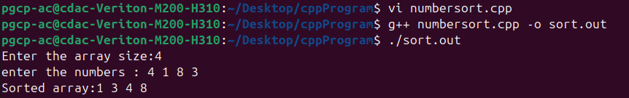

2. Accept n character from user and search a character appears how many time in array

#include<iostream>
using namespace std;
void acceptchar(char* arr, int n){
for(int i=0; i<n; i++){
cin>>arr[i];
}
}
int searchchar(char* arr, int n, char s){
int count=0;
for(int i=0; i<n;i++){
if(arr[i]==s){
count++;
}
}
return count;
}
int main(){
int n;
char s;
cout<<"Enter the size : ";
cin>>n;
char* arr= new char[n];
cout<<"Enter the array : ";
acceptchar(arr, n);
cout<<"Enter the character whose count you want to know:";
cin>>s;
cout<<"The count is:"<<searchchar(arr, n ,s)<<endl;
delete[] arr;
return 0;
}

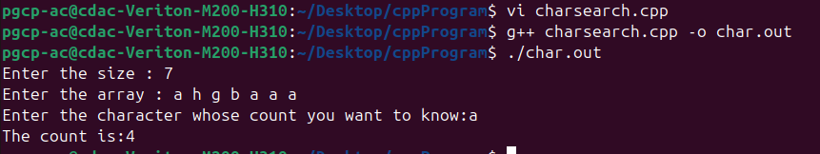

3. Accept n numbers from user and write a function to find out average and display average.

#include<iostream>
using namespace std;

void acceptarr(double* arr,int n){
for(int i=0;i<n;i++){
cin>>arr[i];
}
}
double avg(double* arr,int n){
double sum=0,avg;
for(int i=0;i<n;i++){
sum=sum+arr[i];
}
avg=sum/n;
return avg;
}
int main(){
double* arr;
int n;
cout<<"Enter array size:";
cin>>n;
arr = new double[n];
cout<<"Enter the array: ";
acceptarr(arr,n);
cout<<"average is:"<<avg(arr,n)<<endl;
delete[] arr;
return 0;
}

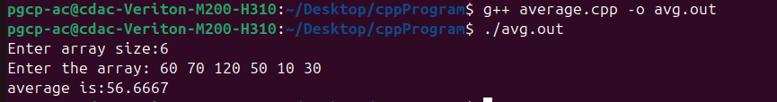

4.Accept n numbers from user and write a function to multiply each number by 2 and display result

#include<iostream>
using namespace std;

void acceptarr(int* arr,int n){
for(int i=0;i<n;i++){
cin>>arr[i];
}
}
void multiply(int* arr,int n){
for(int i=0;i<n;i++){
arr[i]=arr[i]*2;
}
}
void display(int* arr, int n){
for(int i=0;i<n; i++){
cout<<arr[i]<<" ";
}
cout<<endl;
}

int main(){

int n;
cout<<"Enter array size:";
cin>>n;
int* arr= new int[n];
cout<<"Enter the array: ";
acceptarr(arr,n);
multiply(arr, n);
cout<<"The new array is:";
display(arr, n);
delete[] arr;
return 0;
}

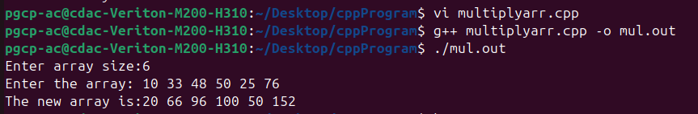

5. Accept n number from user and write functions for finding min,max,second max,second min from these number

#include<iostream>
using namespace std;

void acceptarr(int* arr,int n){
for(int i=0;i<n;i++){
cin>>arr[i];
}
}

void sort(int* arr,int n){
int temp;
for(int i=0;i<n-1;i++){
for(int j=0;j<n-1-i;j++){
if(arr[j]>arr[j+1]){
temp=arr[j];
arr[j]=arr[j+1];
arr[j+1]=temp;
}
}
}
}
int max(int* arr,int n){
return arr[n-1];
}
int min(int *arr){
return arr[0];
}
int smax(int* arr,int n){
return arr[n-2];
}
int smin(int*arr){
return arr[1];
}
int main(){
int* arr;
int n;
cout<<"Enter the size of array:";
cin>>n;
arr =new int[n];
cout<<"Enter the array:";
acceptarr(arr, n);
sort(arr, n);
cout<<"The maximum value is :"<<max(arr, n)<< endl;
cout<<"The second maximum value is :"<<smax(arr, n)<< endl;
cout<<"The minimum value is :"<<min(arr)<< endl;
cout<<"The second minimum value is :"<<smin(arr)<< endl;
delete[] arr;
return 0;
}

